## **Integrations Overview**

OrderCloud.io handles integrations with its partner Jitterbit, a PaaS that can operate in the cloud, on premise, or a hybrid of both, to solve almost any type of data transportation and transformations.

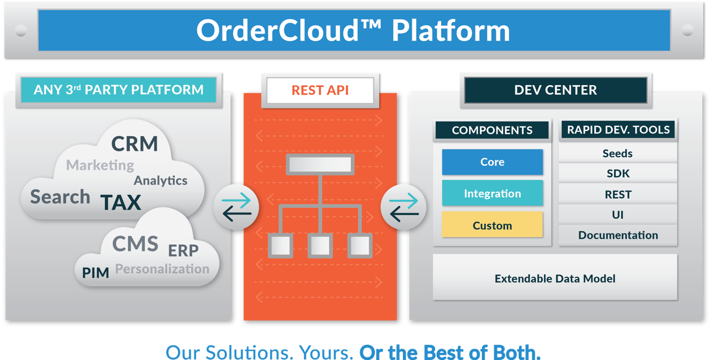

With Jitterbit, OrderCloud.io is able to integrate with a vast variety of ERP and CRM systems. The platform can map and transform your backend data and transport between OrderCloud.io and your systems with on-demand and scheduled jobs. If you are a Salesforce customer, the pre-built connectors can easily import and export data between platforms to reduce data entry and automate business processes.

Click on **Integration Services** in the left nav to view the integrations we currently offer. The Four51 integrations services team can provide integrations to OrderCloud.io with your preferred shipping, tax, or payment services if we don't already have what you need.

For a more detailed list of systems and services OrderCloud.io can integrate with, please visit [Jitterbit](http://www.jitterbit.com/).